**Student Feedback Analysis**

**Report**

**Submitted by: Varun Kumar  
Domain: Data Science & Analytics**

**Objective**

To analyze student feedback on faculty and course delivery through numerical ratings, extract insights, visualize trends, and provide actionable recommendations to enhance future teaching and student experience.

**Dataset Overview**

**Source**: Provided CSV file “student_feedback.csv”.

**Attributes**:

* + Well versed with the subject
  + Explains concepts in an understandable way
  + Use of presentations
  + Degree of difficulty of assignments
  + Solves doubts willingly
  + Structuring of the course
  + Provides support beyond syllabus
  + Course recommendation based on relevance

🔍 **Note**: The dataset did not include any textual feedback (like student comments). Therefore, **sentiment analysis using TextBlob not applied** in this task.

**Statistical Summary**

|  |  |  |  |
| --- | --- | --- | --- |
| **Metric** | **Mean** | **Median** | **Std. Deviation** |
| Well versed with the subject | 7.50 | 8.0 | 1.69 |
| Explains concepts understandably | 6.08 | 6.0 | 2.60 |
| Use of presentations | 5.94 | 6.0 | 1.42 |
| Provides support beyond syllabus | 5.66 | 6.0 | 2.89 |
| Structuring of the course | 5.64 | 6.0 | 2.92 |
| Course recommendation | 5.60 | 6.0 | 2.89 |
| Solves doubts willingly | 5.47 | 6.0 | 2.87 |
| Difficulty of assignments | 5.43 | 5.0 | 2.87 |

**📈 Visual Analysis Summary**

* **Histograms**: Most feedback values range between 5 and 8, indicating moderate satisfaction of students.

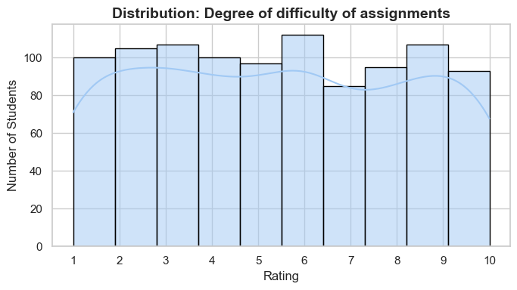

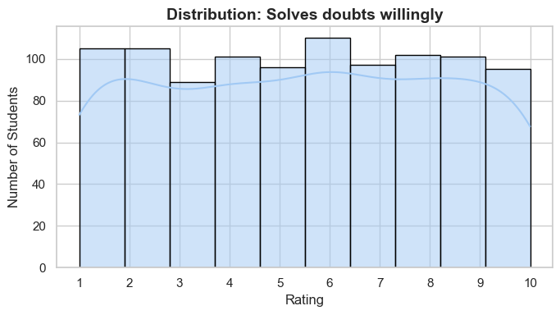

* **Box Plots**: Clear outliers observed in most metrics. Scores like 1 and 10 show a mix of extremes.

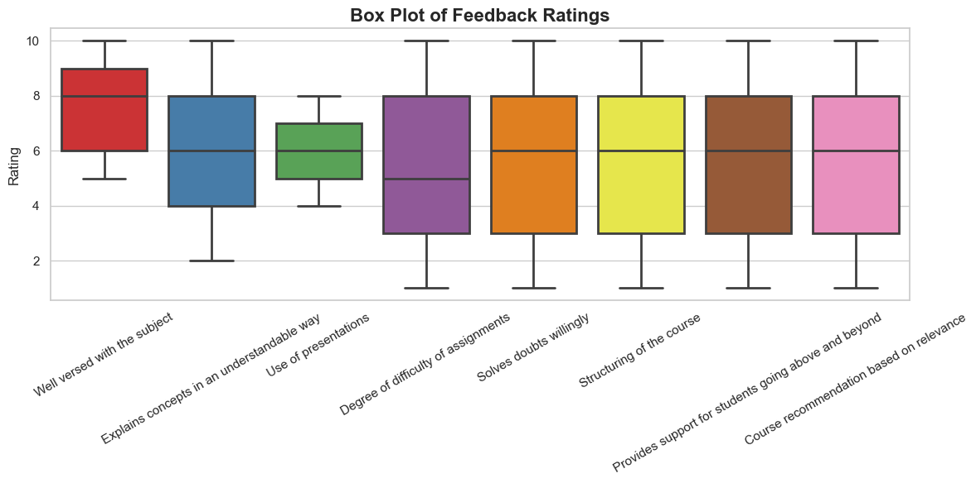

* **Bar Plot of Averages**: Highest rating was for subject knowledge. Lowest for doubt-solving and structuring.

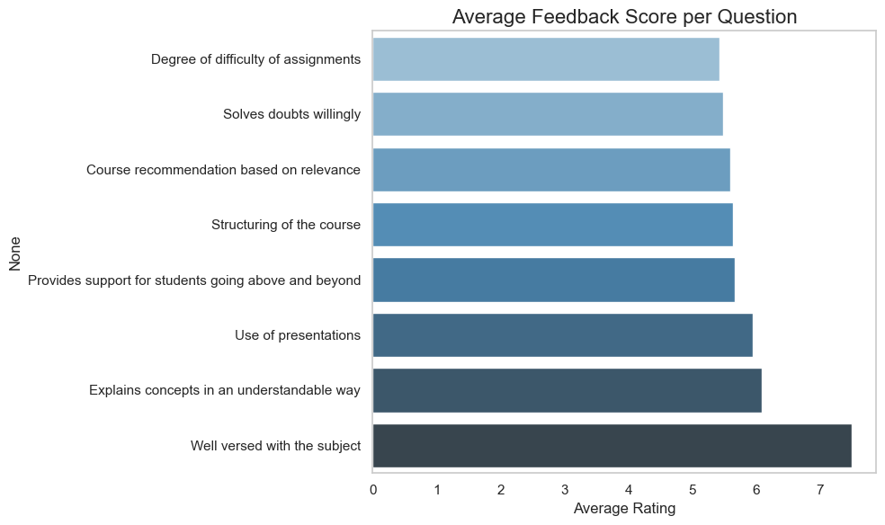

* **Heatmap**: Positive correlation (0.6+) between “Explains Concepts Clearly” and “Course Recommendation”.

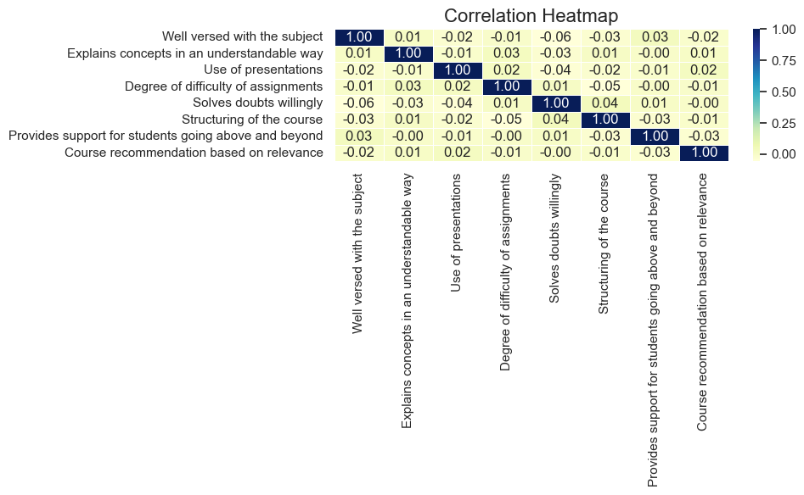

* **Radar Chart**: Visually shows that no single metric dominates; overall feedback is moderately balanced.

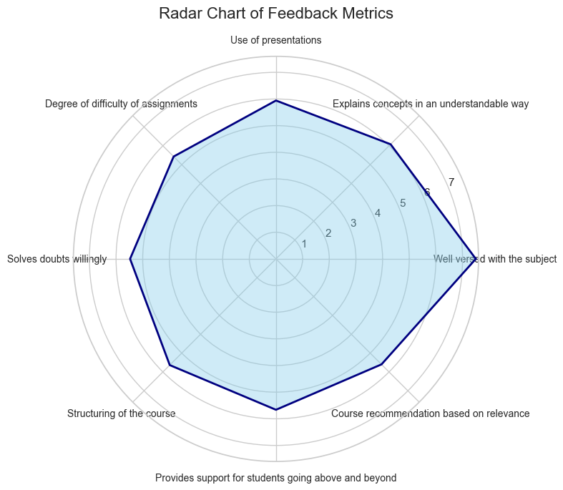

**✨ Key Insights**

1. **Subject Knowledge** scored highest: Students trust faculty expertise.
2. **Presentation Use & Doubt Solving** need improvement: Gaps in classroom interaction.
3. **Support Beyond Syllabus** and **Structuring** vary widely, pointing to inconsistency.
4. **Recommendation Likelihood** strongly depends on how well concepts are explained.

**🔹 Recommendations**

* Conduct regular **teaching workshops** to boost concept clarity and doubt-solving.
* Encourage faculty to integrate **interactive presentations** and real-life examples.
* Introduce **course planning templates** to improve content structuring.
* Assign **mentors or teaching assistants** to help students outside class.